Interfaith Build 2021
Mission
Seeking to put God’s love into action, Habitat for Humanity brings people together to build homes, communities and hope.

What is Interfaith Build?
This year marks Muncie Habitat for Humanity’s 35th anniversary of serving families in our community. Please join us in celebrating this milestone year by participating in our 2021 Interfaith Build. Interfaith Build allows your congregation to put faith into action by participating in a meaningful, hands-on mission in your community. The tangible experiences that Habitat for Humanity provides allows you to engage those around you, live your faith and offer a unique opportunity to love your neighbor. Congregations will have the opportunity to deeply connect with a local family and work alongside them. This work will be done in partnership with other churches and faith organizations, creating an opportunity for groups to work across denominational, racial and religious lines to invest in a strengthened community.

Format of Interfaith Build
Muncie Habitat for Humanity needs fourteen churches and faith groups committed to the construction and sponsorship of the 2021 Interfaith Build home. Participation in Interfaith Build involves a monetary commitment and providing ten volunteers for one build day between June 4, 2021 and July 30, 2021.
- One home
- Fourteen teams
- Ten builders per team
- Fundraising goals:
  - Each team raises a minimum of $500
  - Fourteen combined teams raise a total of $30,000
There has been an unprecedented increase in the costs of building materials in the last year. The increased cost of construction requires us to raise more money than ever before to continue serving families. We are incredibly grateful for the annual support many congregations give and it is our hope that by raising an additional $30,000 through Interfaith Build, we will continue to serve more families.

Example fundraising breakdown:
Number of congregations | Amount raised | Total
1 | $7,500 | $7,500
2 | $5,000 | $10,000
2 | $3,000 | $6,000
4 | $1,000 | $4,000
5 | $500 | $2,500
 |  | $30,000

How will we build?
All faith groups are welcome and no experience is necessary to volunteer. We will teach your group everything you need to know on the construction site and there are a variety of tasks to accommodate all levels of skill and ability. Volunteering together provides a fun, bonding experience for your faith group while deepening your ties to the community we all share.
We are committed to providing a safe construction site for all volunteers. Some steps we are taking to ensure volunteer safety during COVID-19 include requiring masks for all staff and volunteers on site, conducting wellness screenings for each volunteer and staff member, working outdoors with social distancing whenever possible, disinfecting tools at the end of each day and offering individual packaged lunches and beverages.

Commitment/Responsibilities
- Team leader commit by April 30th
- Select your group’s build date between June 4th and July 30th
- Recruit 9 team members
- Raise a minimum of $500
- Work with your team from 9a.m.-3p.m. on your designated build day
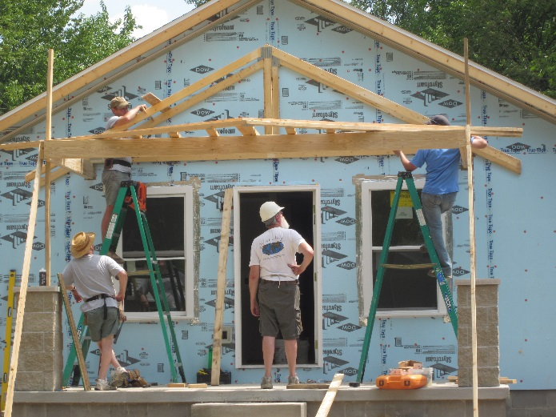
- Help your team reach its fundraising goals
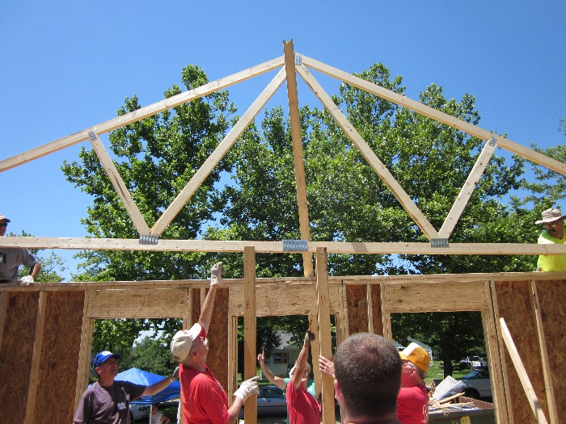
Photos from Muncie Habitat’s 2011 Faith Build

